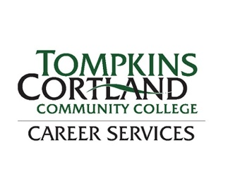
Welcome to Tompkins Cortland
Resume Templates
Room 101

There are four resume templates below (scroll down).
Our templates are Microsoft Word documents, already filled in with example information. This pre-filled information shows you where your information should go and what that information could say. Use this together with our resume guide for full instructions.

To choose a template, first pick one that fits your style and the information. Then either delete all the other pages (including these instructions) OR cut and paste the chosen resume template into a new document.

To use a template, just cover the words with your cursor and retype your information. Make sure to choose information one line at a time to insure you keep the font size and editing. (Yes, you are just typing over the information that is already there). As you type information and lines may move around, just bring them back to alignment by deleting the extra spaces.

To edit the template change the headings and sections to ones that fit your information and freely cut and paste more lines to increase the size of any of the sections.

To load a “Word Document” into “Google Docs” If you are more comfortable with Google Docs, upload this Word file into your google drive and open it up in Google Docs. Some of the information in the template might shift slightly, however it is easy enough to backspace and delete spaces, in order to bring the resume information back into alignment.
Step 1. Open drive.google.com and sign in using your Google account.
Step 2. Click on New in the left hand pane.
Step 3. Click on File upload and locate the Word document you want to convert
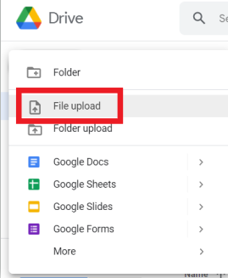
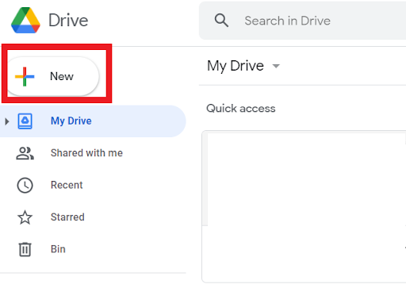

JAMES R. EXAMPLE
170 North Street, Dryden, NY 13053
JR170@hotmail.com
607-555-5555

OBJECTIVE
A law enforcement position. Known for strong work ethic, excellent interpersonal and problem-solving skills

PROFESSIONAL SKILLS
- Excellent communicator, oral and written
- Ability to work in a team
- Developing leadership
- Microsoft Office, computer skills

EDUCATION
A.A.S. CRIMINAL JUSTICE Anticipated Graduation, May 2023 Tompkins Cortland Community College Dryden, NY

RELEVANT COURSEWORK
Criminal Investigation Introduction to Corrections Introduction to Policing

EXPERIENCE

Legal Aspects of Evidence Juvenile Delinquency Introduction to Criminology
RESIDENT ASSISTANT August 2020 - Present
Tompkins Cortland Community College Dryden, NY
        - Enforce residence life policies and create a safe environment for students
        - Create meaningful community programming events for residents
        - Work with emergency services, campus police, and on campus offices
        - On-Call duties 1-2 times a week for 24-hour shifts
SECURITY OFFICER June 2018 – July 2020
Pyramid Mall Ithaca, NY
        - Provided security for daily mall operation, including monitoring customers and employees
        - Worked with a staff of 5 people; helped trained new personnel
        - Conducted security evaluations, investigations, interviews
        - Cooperated with external partners, police and emergency services

ACTIVITIES AND LEADERSHIP

Captain: Basketball, Tompkins Cortland Community College 2016-2017
Vice President of Public Relations: Phi Theta Kappa, Tompkins Cortland Community College 2017

VOLUNTEER SERVICE

Coaching Assistant: Tompkins County Community Youth Basketball 2011-2015
- Helped coach basketball for 6th-8th graders in an after-school program
Jasmine J. Example
1999 Main Street, Cortland, NY · (555) 555-5155· JJE123@icloud.com

EDUCATION

Associate of Science in Liberal Arts and General Studies Expected Graduation May 2023
Tompkins Cortland Community College, Dryden, NY GPA: 3.21, Dean’s List

Relevant Coursework: Foundations of Business, Sales and Sales Management, Business Communications, Psychology, Sociology, Introduction to Early Childhood Education, Report Writing

EMPLOYMENT EXPERIENCE
Resident Assistant, Tompkins Cortland Community College, Dryden NY August 2021 – Present
- Plan and organize bi-monthly programs for 100 residents to foster a welcoming, safe community
- Collaborate with 16 team members to schedule front desk coverage, enforce consistent resident accountability and rules and planned educational programs
- Design and create promotional posters in order to encourage and increase residents’ program
- Organized and designed monthly bulletin boards to educate residents about campus events and health
Customer Service Representative, Mountain Play Lodge, Lake Placid NY June 2020 – May 2021
  - Supervised 20 children ages 3 - 12 years old while maintaining a safe educational environment
  - Balanced cash receipts and justified daily sales to insure accurate revenue accounting
  - Coordinated and directed birthday parties as party attendant resulting in memorable and fun events
Grocery Cashier, Price Chopper, Lake Placid NY June 2018 – May 2020
  - Operated digital cash register and helped customers in a busy local grocery store
  - Assisted with inventory, stocking, bank deposits and closing procedures

COMMUNITY SERVICE
Volunteer Teacher, Blue Ridge Literacy Council, Flat Rock NC February 2016-May 2017
  - Taught literacy skills to four adults 5 hours per week, helping clients read the newspaper, write resumes and develop computer skills

CAMPUS LEADERSHIP
President: Active Minds, student club, TC3 Dryden NY September 2021 – Present
Member of the Society Toastmasters, Ithaca NY February 2020- May 2021

HONORS AND AWARDS
Officer, Phi Theta Sigma National Honor Society, TC3 Dryden NY 2020-Present

SKILLS
Proficient in Microsoft Office Suite: Word, Excel, PowerPoint Languages: Fluent in Spanish and English
Irene Example
Avenue, Apt 100
Ithaca, NY 14850
(555) 555-5555
Irene.Ex@hotmail.com www.linkedin.com/in/IreneEx

Summary
Seeking a teaching position where I am able to utilize my diverse educational background and leadership skills. Enjoy working independently and with a community of professionals.

Skills
- Teach children 2- 11 years

- Flexible and organized

- Microsoft Office 365

- Computer, Web & App ability

- Patient and outgoing

- Problem solving skills

- Works well independently

- Excellent in group situations

Certifications & Awards
- CPR Certified 2020
- TC3 Dean’s List 2021

Education
A.S. Liberal Arts & Sciences General Studies Expected Graduation May 2023 Tompkins Cortland Community College Dryden, NY GPA: 3.0
Relevant Coursework
Word, Spreadsheets and Databases Design and Visual Communication Children and the Arts Early Childhood Development
Beginning Spanish Early Childhood Education

Early Childhood Education September 2018 - June 2020 TST BOCES Career & Tech Center Ithaca, NY

Work Experience
Teacher Assistant February 2019 - Present
Trinity Ithaca Preschool Ithaca, NY
  - Work with lead teacher to organize weekly classes
  - Create and teach lessons and activities for ages 6 to 11
  - Set up larger events with other staff, including holidays and fundraisers

Daycare Assistant, Intern December 2019 - February 2020
TC Action, Harriet Center Ithaca, NY
  - Plan and lead lesson plans for children ages 1-2 each week
  - Worked with the different needs of infants and preschoolers
  - Assisted classroom teacher with lessons and management as needed

Preschool Assistant, Intern September 2019 - November 2019 Aspen Grove Preschool Ithaca, NY
  - Planned curriculum and lead classes for children ages 3-5 each week
  - Interacted with kids with different physical and learning needs
  - Assisted classroom teacher as needed

Summer Camp Counselor June 2018 – September 2018
Ithaca Children’s Garden Ithaca, NY
  - Planned and lead children's activities in local community garden
  - Worked with garden tools, weeding, making trails, and composting,

Volunteer Experience
Student Teacher September 2018 – May 2019 TST BOCES Preschool Ithaca, NY
  - Planned with lead teacher and art lessons for children ages 3 to 5
  - Worked with infants, toddlers and preschoolers
  - Conducted Parent Conference

555-555-5555
Markus Example
That Road Candor, NY 13743
MarkusEx@gmail.com
www.linkedin.com/in/MarkusEx

EDUCATION SUMMMARY

A.A.S. Human Service Anticipated Dec. 2023 Tompkins Cortland Community College Dryden, NY GPA of 3.2 - Deans List
Relevant Coursework
    - Generalist Social Work Practice
    - Applied Methods in Human Services
    - Society, Race, Power and Privilege
    - Alcohol & Alcoholism
    - Childhood Psychology
    - Disability Studies

Certified Nursing Assistant Sept. 2018- June 2019
Broome Tioga BOCES Binghamton, NY

WORK EXPERIENCE
Certified Nursing Assistant Oct. 2020- Feb. 2022 Oak Hill Manor Ithaca, NY
    - Worked with a team of staff assisting treatment of patients
    - Performed traditional aid functions in accordance with policy
    - Assist with recreational activities and community outings
Certified Nursing Assistant Aug. 2019 – Jan. 2020 River View Manor Owego, NY
    - Provide routine daily resident care services to residents
    - Follow assessment and treatment care plans
    - Maintain environment and assist unit manager and charge nurse
    - Able to lift 70+ pounds and safely move residents in beds

Substitute Teacher Feb. 2017 - June 2017
Spencer School District Spencer, NY
    - Elementary substitute teacher for grades 3-5, science and math
    - Worked with teachers on curriculum planning and management

VOLUNTEER EXPERIENCE
Gardener, lead activities for youth Sept. 2020- Current Ithaca Community Gardens Ithaca, NY
With an Associate’s degree in Human Services, experience in assistant nursing and a passion for helping others, I am looking for a position at a local community agency or non-profit organization.

SKILLS

- Communication Skills
- Bilingual English and Spanish (moderate)
- Team Player
- Extremely Organized
- Confidentiality Trained
- Strong Work Ethic
- Work well Independently
- Microsoft Office 365

CERTIFICATIONS

NYS Certified Nursing Assistant
2019-2023

Mandated Reporter Training
2020
ORGANIZATIONS

National Society of Leadership and Success
2020-2021

