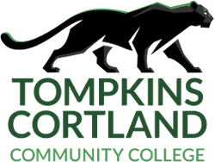
Health and Wellness Services
Health Center
Room 118A
607 844-8222 x 4487
healthcenter@tompkinscortland.edu

Remote/Online Attestation Form
This form is required for all unvaccinated students who are fully remote

1. I am the person named below who attends Tompkins Cortland Community College.

2. I understand that all Tompkins Cortland students who are enrolled in a class with an on-campus component must provide proof of their immunization records (MMR and Meningitis) or attest that they will not be attending class on the TC3 main campus or extension centers.

3. I have read and understand this statement and sign it with full knowledge of its meaning and content.

Printed Name:

Signature:

Student ID #: Date:

