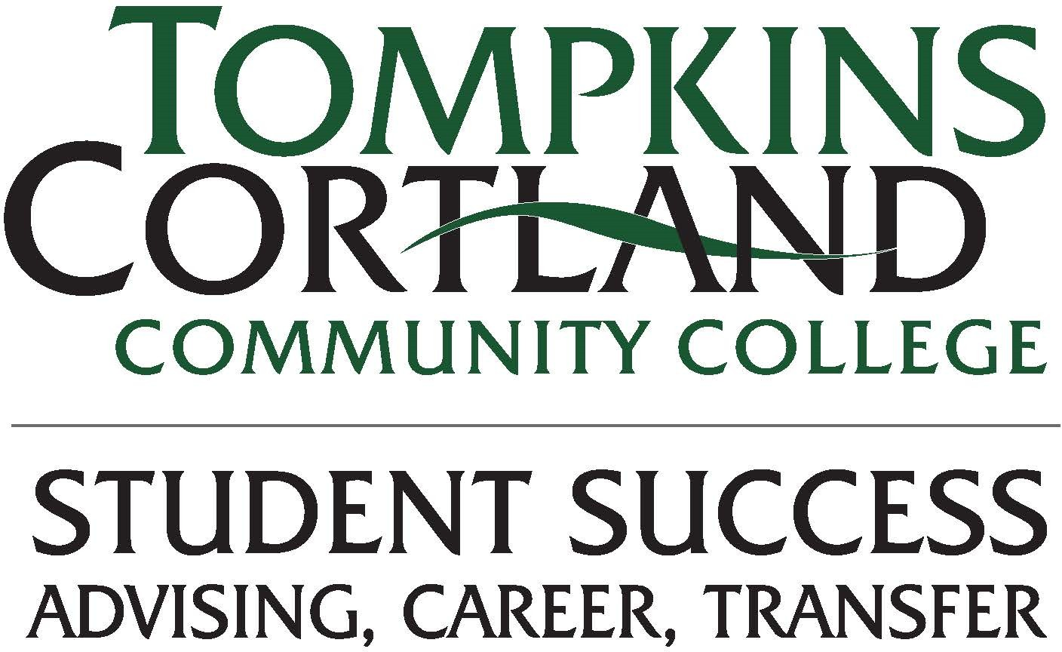

Academic Recovery

Checklist

Review expectations and Campus Resources:
☐ Purchase all textbooks and required materials before the semester begins, if applicable.
☐ Attend all class meetings for every course in which you are enrolled, arrive on time, and stay for the full class.
☐ Check your Tompkins Cortland myMAIL at least 3 times per week, if not every day.
☐ Meet with your academic advisor in the first two weeks of the semester and follow up as needed.
☐ Check your early progress indicators. Available week six of the semester.
☐ Communicate with your instructors any time you miss class for an illness/emergency.
☐ Communicate with your instructors any time you are concerned about your progress.
☐ Use the campus resources listed in your Success Plan (Found in Starfish) to support your success.
☐ Do not adjust your schedule without speaking to your academic advisor or a Student Success Advisor.
☐ Participation in the Mentor Advising Connection (MAC) program: an initiative that links you with an academic success coach/tutor from the Baker Center for Learning.

